**Chapter 1**

# Introduction

# License

This document is released under the Simplified BSD license.

# 1.1 Introduction

The NASA Student Launch Mini Mars Ascent Vehicle project1 is part of an annual competition, the NASA Student Launch. The project is a research based, competitive, exploration project providing relevant research and development experience to the participants. In this year’s competition, we are building a high powered rocket which we will be launching to an altitude of 3,000 feet above ground level. Before launch, our Autonomous Ground Support Equipment (AGSE), will load and secure a payload, provided by NASA, into the rocket. Specific competition requirements include:

* Carry a payload approximately ¾ inches in diameter and 4 ¾ inches long with a weight of approximately 4 ounces.
* Deliver the payload to, but not exceeding, an apogee of 3,000 feet above ground level
* The vehicle will carry one commercially available, barometric altimeter for recording the official altitude.
* The launch vehicle must be recoverable and reusable. (No repairs needed after the launch)
* The vehicle must contain an electronic tracking device which will transmit its location to a ground receiver.
* The payload will be loaded autonomously. There will be one power switch and one pause button. During this process, the team is not permitted to interact with the vehicle or AGSE.
* The AGSE many not use: Sensors which rely on the earth’s magnetic fields, ultrasonic or sound based sensors, radio aids, open circuit pneumatics, air breathing systems.

This year a group of students from varying backgrounds has formed a team, UAA Rocketry, to compete in the competition. We are working together, across disciplines, to enter the 2015 NASA Student Launch competition. The team consists of five mechanical engineering students, one business student, and one computer science student with guidance from a National Association of Rocketry (NAR) representative.

Team Members:

* Stephen Arwine – Mechanical Engineering
* Jordan Shindle – Mechanical Engineering
* Brandon Grimshaw – Mechanical Engineering
* Brian Beechinor – Mechanical Engineering
* Jacob Dempsey – Computer Science
* Carolyn Forner – Business Management

Guidance Provided by:

* David Erickson – NAR representative

The mechanical engineering students are designing the rocket, launch platform, and the Autonomous Ground Support Equipment (AGSE). The business major is helping to organize efforts, setup appointments including presentations to the public, and secure donations of equipment and funds. As the computer science student, I am designing and building the team website, assisting with the selection of all electronic components used in the rocket and AGSE, and programming the AGSE to load the payload.

We will be using off the shelf components where appropriate, and designing custom components when they will provide the best utility for the project.

My portion of the project will be broken down into three primary sections:

1. **Website**

The website will be our primary method of providing information to NASA through the project. It will also be a promotional tool used to promote the UAA Rocketry Team specifically, and STEM generally to the community. The website address we will be using is <http://www.UAARocketry.com>. We will be using WordPress2 as our content management system, and I will be creating a custom theme for WordPress using PHP, JavaScript, and CSS as well as creating custom graphics for the site and the WordPress theme.

1. **Rocket, Launch Pad, and AGSE electronics selection, assembly, and testing.**

The electronics will include: the rocket’s altimeter; the rocket’s GPS location tracking hardware; and the controls and motors for the AGSE.

1. **Programming the AGSE.**

The AGSE will acquire and load a payload provided by NASA, into the rocket before launch.

# 1.2 Application

The project has direct applications in aerospace, particularly as it applies to NASA. It also has applications in robotics with the AGSE. Finally, it has applications in mass communication via the internet with the development and publishing of the team’s website.

I will be gaining experience providing web development services as I explore the options available to publish the team’s content to the web. I will be gaining experience and insight into the robotics design as I help select the electronic components and do the programming for the AGSE.

# 1.3 Motivation

My motivation for this project is multi-faceted. First, I wanted to do an interdisciplinary team project, as I believe this provides a more realistic real world experience. Second, I wanted to participate in a project which would be out of the ordinary. Third, I have always found robotic systems to be very interesting. This project fulfills all of these goals. The project as a whole would be difficult for any one person to provide all of the necessary skills lending itself very well to an interdisciplinary project. I am not aware of anyone from UAA participating in a project like this, which for me, makes it out of the ordinary. While my involvement in the project covers a wide scope, I am most excited about helping to design and eventually program the AGSE.

# 1.4 Recent Developments

In recent years, the size and power requirements have been decreasing. These developments are allowing us to house sophisticated electronic devices in our rocket, as well as in the creation of our AGSE. We are exploiting the development to create a cutting edge rocket and AGSE for the upcoming NASA competition.

# 1.5 Initial Design

## 1.5.1 Website

The website is being hosted by Jacob’s CHAOS on my server space. We chose to use my server space as there is no associated cost, and I am already very familiar with the environment.

We are using WordPress as the base of the content management system (CMS). After comparing features and user experiences, we chose to use WordPress as our CMS. While this will be the first project which I have developed for WordPress, I am confident that my previous experience with developing static and database driven websites as well as templates for other CMS systems will serve me well in developing a theme for it.

I will be using _s (under scores3) as a base for developing the word press theme. It is designed as a starting point for new WordPress themes. It has very little formatting initially, but has a well-defined structure for building the theme. See **figure 1** for a layout of the technology for the website.



Figure 1: Website technology layout

I will be coding in html, php, javascript, and CSS to create the theme.

Team requirement for the site:

* Professional looking site (I will be using black text on a white background and clean lines to keep the website professional looking)
* Easy to update (Functionality provided by WordPress)
* Unique with a Space/Alaska design which will let people know at a glance they are on the UAA Rocketry website (I will be creating a star field for the background which will give a parallax scrolling effect when scrolling up or down the page. I will also be using a transparent aurora borealis (northern lights) image in the site header to build a stronger visual tie to the north and Alaska.

The physical pages and their relation to one another will be decided by the team.

## 1.5.2 Electronics

We will be using an off the shelf altimeter per NASA’s requirement.

We will be using an off the shelf GPS location system.

We will be using an off the shelf ignition system.

We will be using a Beaglebone Black4 for the AGSE controller. Given the relatively low price of the Beaglebone, Beaglebone Black, and Rasberry Pi; I chose to use the Beaglebone Black for the added memory and computational power. However, I believe we could have used one of the less powerful options.

We will use off the shelf stepper motors and motor controllers for manipulating the arm and end effector.

## 1.5.3 AGSE Design

The AGSE will consist of four main components: the mounting base, the housing, an arm, and an end effector. The mounting base will provide the stability for the AGSE, the housing will enclose the electronic controls, while the arm and end effector will provide the utility for picking up the payload.

**Figure 2** is our preliminary design for our Rocket and AGSE.

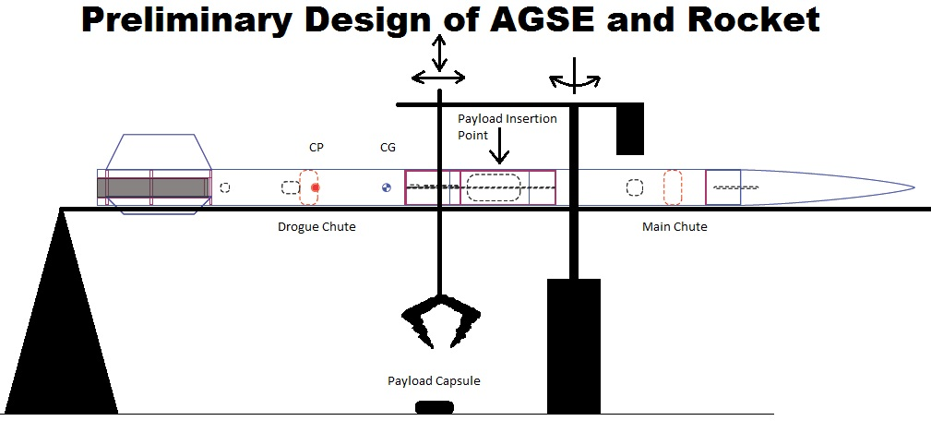

Figure 2: AGSE

We have continued to refine our design for both the rocket and the AGSE. The mechanical engineering students have been working in SolidWorks to create and render the design. **Figure 3** provides a look at a potential AGSE with the rocket, while **Figure 4** provides an alternative design to the AGSE.

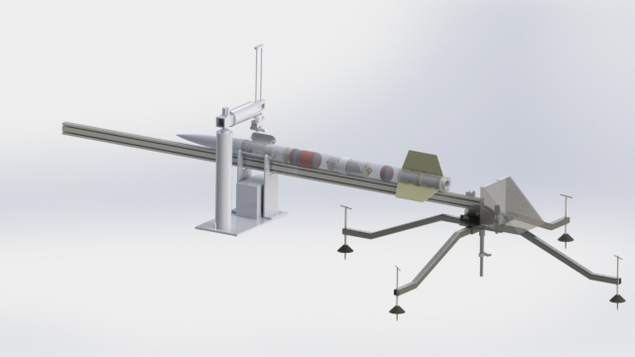

Figure 3: AGSE and Rocket SolidWorks rendering

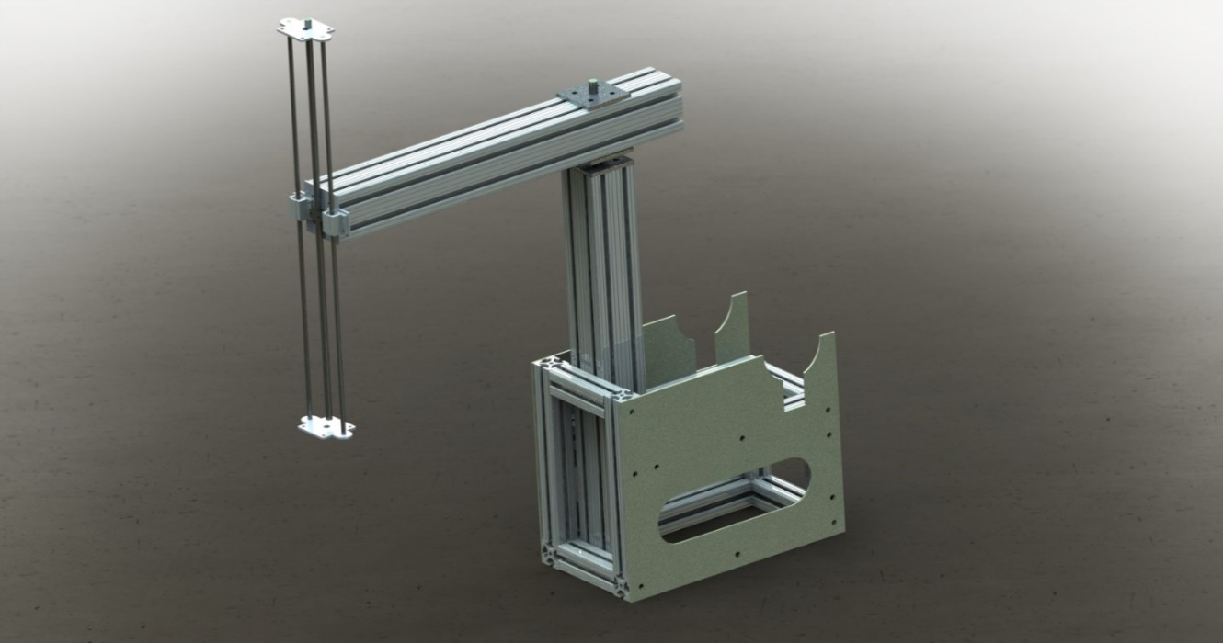

Figure 4: Alternate AGSE SolidWorks rendering

We will continue to refine our design until we are ready to build our full scale system.

## 1.5.4 AGSE programming

I will be programming the AGSE in C++ using eclipse5 as my editor and cross compiling using GCC.

**Figure 5** shows the basic UML diagram for the arm controller.



Figure 5: UML Diagram for AGSE

# Appendix A: References

[1] NASA, http://www.nasa.gov/audience/forstudents/studentlaunch/home/, retrieved 2/3/2015.

[2] WordPress, https://wordpress.org/, retrieved 2/3/2015.

[3] _S, http://underscores.me/, retrieved 2/3/2015

[4] Beagleboard, http://beagleboard.org/black, retrieved 2/3/2015

[5] Eclipse, https://eclipse.org/downloads/packages/eclipse-ide-cc-developers/lunasr1a, retrieved 2/3/2015

# Appendix B: Code and Documentation

WordPress theme code:

https://github.com/jadempsey/UAARocketry/tree/master/WP%20rocketry%20theme

Doxygen Documentation:

https://github.com/jadempsey/UAARocketry/tree/master/doxygen